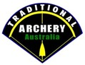 **Traditional Archery**

**Information for New Members**

CLUB ADDRESS

E: P:

You can also find us on Facebook.

“CLUB LOGO”

Welcome to CLUB NAME. We hope you enjoy your shoot day with us.

CLUB NAME and TAA Information:

Our club is part of the National Traditional Archery Group TAA inc. TAA started in 2006 and became an incorporated association in 2014. They were set up to promote and protect traditional archery within Australia. They are happy to work with other archery groups with the same goals.

TAA currently have 26 Clubs affiliated throughout Australia and growing. Our Club is proud to be one of these clubs. We encourage you to visit the TAA website to find out more about this great sport of Traditional Archery.

[www.traditionalarcheryaustralia.org](http://www.traditionalarcheryaustralia.org)

All new CLUB NAME members must complete this course or demonstrate to the CLUB NAME Committee members that you can be a safe and proficient archer. If you have not completed an Introduction/Beginner course at a reputable archery club, we require you to attend one of our Come and Try Days.

We currently shoot every DATES.TIMES. The 2nd Sunday is Come and Try and Club Shoot. The 4th Sunday Working Bee and Club Shoot.(Suggestion only - change this to suit your clubs calendar)

**CLUB NAME**

**Club Coach/President Name**

**P:**

**E:**

Membership Fees:

All Members Must have current TAA membership. Arranged through CLUB NAME or TAA.

TAA membership is $---.00 pa. Family and Jnr. Discounts apply.

Club Membership is $--.00 pa.

Shoot fees are $--.00 for members and $--.00 for visitors. (Visitors are Limited to 3 visits a year unless a member of the Archery Alliance.)

Come and try. $--.00. Must pre-book and pre-pay.

Archery Alliance Members are welcome to shoot for $--.00. On presentation of their organisation member card. ABA, AA and 3DAAA members.

Come and Try archers start at TIME sharp and finish at about TIME

If you would like to become a Club Member complete the attached forms as required.

It is a TAA and club name requirement that all coaches running this, or the Instructors Course must have a Working with Children clearance and approved as a Coach by TAA and club name.

Thank you for your support and participation in our Come and Try Day.

SAFETY FIRST, ALWAYS  
Your archery course Officer will make sure you are as safe as possible. However, there are dangers that need to be discussed and addressed. Injury can be caused not only by an arrow!

If you have not been advised of the following, ask!

1. Where are the toilets?
2. First Aid Kit Location.
3. Fire assembly point and evacuation route.
4. Water access on hot days.
5. Has your equipment been safety checked by the instructor?
6. Snakes have been seen!
7. Any other relevant safe issue/s

Have you got:

1. Enclosed shoes.
2. Sun protection. Hat and Sun Block.
3. Rain protection if applicable.
4. We strongly suggest long trousers.

Do not!

1. Nock your arrow/load your bow before being asked to or if there is anyone to your front!
2. Walk directly towards targets. Arrows in the ground could injure you.
3. **When archers are pulling their arrows from targets, DO NOT stand behind them. More injuries occur from the nock of arrows than the points.**

Must Do!

1. Before releasing your arrow, shooting, make sure there is no persons or animals in your view. Behind or to the sides of the target.
2. If the Instructor/Coach/Safety Officer calls Shoot or one short whistle blast. Start shooting if safe to do so.
3. If the Instructor/Coach/Safety Officer calls collect arrows. Two short whistle blasts collect and score.
4. If the Instructor/Coach/Safety Officer calls STOP or more than two whistle blasts. Do not shoot. Arrows in quivers and step off the shooting line.  
   **REMOVE THE ARROW FROM YOUR BOW!**

There are many more safety issues at the range. Always listen to your club instructor/Coach and experienced archers.

ASK QUESTIONS! BE SAFE!

**The type of Bows we shoot.**

**Primitive bows** are any bow of any design that doesn’t have fiberglass, carbon, or other synthetic material in its construction. This includes all aspects of the bow, such as, overlays etc. The primitive bow division includes self-bows (bows constructed of one piece of wood) or all wood composites (bows constructed with multiple laminations of wood or bamboo or any natural material).

**Longbows:**

* Longbow refers to the traditional straight end style longbow. In some circles these are also known as American Flatbows.
* When strung the profile of the longbow’s limbs shall show a single continuous curve at brace height, the string will not touch the belly of the bow at all and if a string was laid along the back of the bow from handle to string groove, it is to have no areas where light shows between.
* A longbow can be of any material or use any modern glue in its construction.
* The riser is to be free of any marks or blemishes that can be used for sighting.
* A longbow may have a shelf cut into the handle, but it must not be Centre shot.
* A longbow may have an elevated arrow rest such as a toothbrush style rest or a protruding flap or fold of leather attached to a strike plate. Stick on plastic rests and mechanical rests are not permitted.
* A longbow may have a straight, dished or locator grip.
* Pistol grips are not permitted. A pistol grip shall be defined as having a palm swell and on the offside from the palm swell a sharp edge or shelf on a contour the thumb rests on.
* The Longbow can be of takedown construction but two piece only. Three-piece construction, ILF etc., will be considered as hybrid bows and should be placed in that division.
* The bow must be shot with one finger touching the arrow. A finger tab or glove is permitted.
* One permanent nocking point is to be used and may be marked by one or two nock locators.
* No draw check, release or sighting aids are permitted.
* Bow mounted, wrist or finger slings are not permitted.
* Limb savers are not permitted.
* String silencers and brush buttons are permitted but must be at least 12 inches/30cm above and below the nocking point.
* Stabilizers and additional weight for the purpose of balancing the bow is not permitted.
* Bow quivers are permitted so long as the attachment points do not protrude into the sight window.

**Modern Recurve**

* A modern recurve bow can be one piece or can be taken down in two or more parts.
* The riser may be constructed of any material. ILF (international Limb Fitting) and risers with similar mechanical adjustment are permitted. No adjustments to the riser’s mechanism are allowed to be made during a tournament.
* The riser is to be free of any marks or blemishes that can be used for sighting. The limbs may be constructed of any material.
* A modern recurve’s sight window can be cut to any degree of Centre shot.
* The bow must be shot with one finger touching the arrow. A finger tab or glove is permitted. One permanent nocking point is to be used and may be marked by one or two nock locators. No draw check, release or sighting aids are permitted.
* Bow mounted, wrist or finger slings are not permitted.
* The bow may be shot off the shelf. Elevated arrow rests are permitted but pressure buttons and mechanical arrow rests, such as, flipper, drop away are not permitted.
* Limb savers are not permitted.
* The recurve may have any grip style.
* String silencers and brush buttons are permitted but must be at least 12 inches/30cm above and below the nocking point.
* Stabilizers and additional weight for the purpose of balancing the bow is not permitted.
* Bow quivers are permitted so long as the attachment points do not protrude into the sight window.
* In the case of mechanical failure authorization to make the repair/adjustment must be sought from a Tournament Official.

**Traditional Recurve**

* A traditional recurve may be of laminated fiberglass and timber construction. The riser of the bow should be made mainly of wood. Phenolic and other synthetic materials are permitted so long as they are not the sole material used in the riser.
* The limbs must have a wood core. Synthetic core laminations are not permitted. They may be laminated on the back and belly with, for example, fiberglass or carbon fiber. If a recurve bow has synthetic core laminations it is classed as a modern recurve.
* A recurve bow can be one piece or can be taken down in two or more parts.
* The riser is to be free of any marks or blemishes that can be used for sighting.
* Adjustable ILF, formula or similar adjustment systems are not permitted, they are shot in the modern recurve division.
* No draw check, release or sighting aids are permitted.
* The bow may be shot off the shelf or from a non-mechanical, elevated arrow rest. Cushion plungers are not permitted.
* The bow must be shot with one finger touching the arrow. A finger tab or glove is permitted.
* One permanent nocking point is to be used and may be marked by one or two nock locators. The recurve may have any grip style.
* Limb savers are not permitted.
* String silencers and brush buttons are permitted but must be at least 12 inches/30cm above and below the nocking point.
* Stabilizers and additional weight for the purpose of balancing the bow is not permitted.
* Bow quivers are permitted so long as the attachment points do not protrude into the sight window.

**Asymmetric bow designs (Asiatic Bows)**

* Hungarian, Turkish, Mongol, Assyrian, Tartar, or similar Asiatic styled bows (sometimes referred to as horse bows) are defined as Asiatic.
* Asiatic Bows generally have static tips known as Siyahs.
* These bows can be made from any materials including fiberglass and carbon fiber. Natural composite construction Asiatic bows are encouraged.
* These bows cannot have a pistol grip or a large riser as per modern or traditional recurves. The riser is to be free of any marks or blemishes that can be used for sighting.
* No shelf is to be cut into the handle/ riser. A strike plate is permitted Asiatic bows must be shot off the hand; a shelf of any type is not permitted.
* Thumb rings are permitted however if the Asiatic bow is shot using a finger release it must be shot with one finger touching the arrow. A finger tab or glove is permitted.
* One permanent nocking point is to be used and may be marked by one or two nock locators. Limb savers are not permitted.
* String silencers and brush buttons are permitted but must be at least 12 inches/30cm above and below the nocking point.
* Stabilizers and additional weight for the purpose of balancing the bow is not permitted.
* Bow quivers are permitted so long as the attachment points do not protrude into the archer’s peripheral vision.

**Arrows**

Traditional archers prefer wooden shafts. Club Name are happy for you to use any shaft that is safe. Materials currently used are Wood, Aluminum and carbon. Please ask your Coach before choosing arrows. They must be of good quality and well made. It is best to purchase arrows through your club or a reputable archery shop. NOT EBAY unless you know what you are doing.

Special attention should be paid to wooden shafts. Check your arrows before every shoot. If your arrow is damaged get someone that knows what they are doing to check and repair. It is better throwing a shaft away than losing an eye!

Special attention should also be paid to Carbon Arrows. Carbon Splinters are very dangerous. Once in your system they can’t be detected.

We recommend well-maintained wooded or aluminums shafts. Most traditional clubs will only use wooden shaft arrows. All trad shoots check with the clubs

|  |
| --- |
| Your notes: |
|  |
|  |
|  |
|  |
|  |
|  |
|  |
|  |
|  |
|  |
|  |
|  |
|  |
|  |
|  |

**Shooting a Bow**

**Step 1. Stance/feet position**

Because of the terrain we shoot it can be difficult to find level ground to shoot from, so it’s important to look and find a secure comfortable shooting position.

There will be situations from the shooting position where you have no choice but to kneel or stretch out due to the terrain, in this case you will have to try and adapt your stance, always position yourself in a comfortable and secure way.

1. **Open stance.** The preferred stance.

Place feet a shoulder width apart, Toes of your draw foot moved 4 inches in front of the toes of the bow foot, now pivot the front foot towards the target by 30 degrees and the back foot away by 10 degrees, shift 70% of your body weight onto the balls of your feet.

2.**Closed stance.** Optional.

Place your feet a shoulder width apart, both feet should be even with each other, shoulders and hips parallel to the target. Now shift 70% of your body weight onto the balls of your feet.

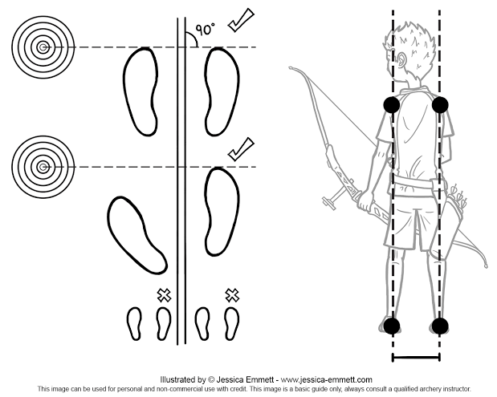

**Step 2. Holding the bow**

Holding or gripping the bow is an important point and is often overlooked and substantial mistakes can be made.

How you hold the bow can influence the arrows flight, this is more evident using a tradition style bow.

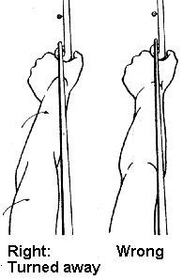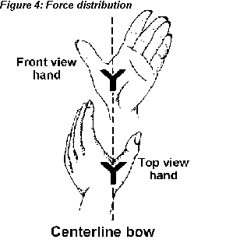 A right-hand archer holds the bow in the left hand and a left-hand archer holds the bow in your right hand, now position the bow grip slightly to the left of your lifeline at a 45 Degree angle. The pressure point as you draw the bow should sit in the middle of the bow grip (mid pressure), hold the bow gently in your hand. (soft hands) Do not choke the bow handle. Do not push down hard with your lower palm on the handle.

**Step 3. Holding the string**

The two main methods to hold the string are **Mediterranean loose** split fingers or **Apache** three fingers under, both these methods are of personal preference to the archer.

Nock the arrow on the string below the nock point with the index feather pointing out. The string should sit in the first joints from the tip end of the fingers. Hook your fingers around the string keeping them relaxed. Shooting split finger style be careful not to pinch down on the nock leave a little room between the nock and your fingers. Make sure your fingers and the back of your hand are in a straight line with your draw arm.

3 fingers under style, your index finger should just be touching the nock for consistency. With both styles your thumb should be tucked into your palm and touching the base of the little finger.

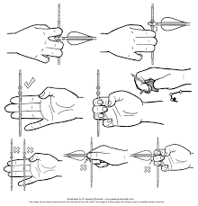

**Step 4. Carrying out the draw**

Keeping your head still Look and focus on the target, lift your bow up and point the arrow directly at the target, the bow arm and the draw arm should be in a horizontal line, shoulder height.

Keep your bow arm straight and the shoulder in a low locked position. The elbow should be turned out and away from the bow string.

Now Start to draw the bow string back smoothly and constantly using your back muscles (back tension) move your shoulder blades towards your spine, the draw arm shoulder rolls around towards your back, keep drawing until you have reached your anchor point. The diagram below is the correct alignment and position of the bow arm this is your goal.

* At full draw, both shoulder blades are drawn evenly together.
* at full draw, the back is straight and stretched.
* at full draw, the arrow, bow arm and draw arm are in line.
* At full draw, you are exactly positioned on your anchor point.
* at full draw, keep your back tension engaged throughout the shot.

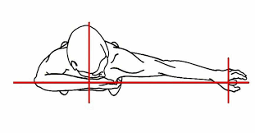

**Step 5. The anchor Point**

Your anchor point is a fixed consistent position on the side of your face, usually behind the eye tooth.

Your middle finger will give you a high anchor point or your index finger will give you a low anchor point this option is ideal for archers who wear glasses.

When you have reached your anchor point Press your hand tight against your face with your index or middle finger located behind the eye tooth. **Whatever you choose it must be the same every time.**

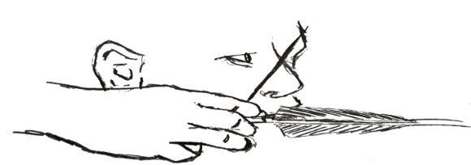

**Step 6. Releasing the string**

The length of time between to when the bow is drawn to anchor and releasing the string should be no more than two to four seconds, this may vary from archer to archer. (Shot timing).

**DO NOT** hold the shot for too long or you fatigue quickly and spoil the shot.

At full draw momentarily pause when you have reached your anchor point, this time is to make any final adjustments to your aim. At all times you are **focused** on the target.

Using your back tension continue the draw on the string while staying at your anchor point, now start to relax your draw hand and fingers with this backwards tension you will feel your fingers wanting to open and your anchor point wanting shift back, this is the time to release the string and follow through with the bow. This is called expanding into the shot.

Consciously do not open your hand and force your fingers off the string all you need to do is relax the hand and fingers.

With the correct alignment and back tension, the draw hand should automatically fall relaxed onto the shoulder.

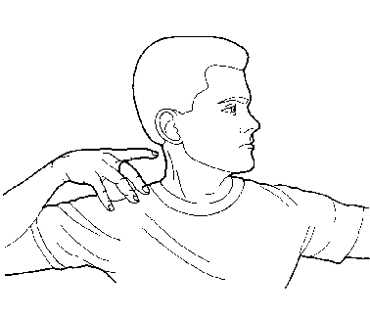 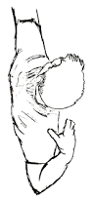

**Step 7. Follow through**

This is the final stage of the shot, and you must consider the follow through with the bow. Your release and follow through are a single fluid smooth action. (Rhythm)

Continue to engage your back muscles. (Back tension)

Upon releasing the string, the draw arm, hand and fingers should be relaxed.

The draw hand should move back along the side of the face and finish on the shoulder just under the ear.

The bow arm should continue to hold the bow up until the arrow hits the target.

Finally lower the bow and rest.

**DO NOT** hold the bow string for too long you will fatigue quickly and collapse on the shot.

**DO NOT** move the bow to the left or right upon release (peaking)

**DO NOT** drop the bow arm, hold it up in its original position until the arrow hits the target.

**Measure draw length**

When you have settled into YOUR form and comfortable with your shooting style. Get your Coach or a club qualified person to measure your draw length on your arrow.

**Brace height**

The brace height is the distance from the deepest point on the handle grip to the string when the bow is strung.

Modifying the brace height can have serious impacts on the bow’s performance and overall shooting characteristics, this is an important and technical adjustment for fine tuning your bow and for optimum performance.

You can change the speed of the arrow by changing the brace height. This not only effects the velocity of the arrow but also your accuracy and the bows noise development.

Beginners often neglect the brace height, when left unchecked it can become low and slap the forearm or even the thumb, adjustments need to be made. Reset the brace height.

A new string it will stretch how much will depend on the string material used, to shorten the string simply remove one end of the string off the bow and spin in the directions of the twist, to lengthen the string spin in the opposite direction.

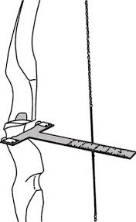

**The correct brace for your bow! Check with the manufacturer.**

**The nock Point.**

The nock point is the second important adjustment of your bow.

Without setting the nock point correctly the arrows flight will be erratic (upward and downward movements) and lose a lot of energy.

The nock point setting will be different for every archer, it is an individual measurement, and this will depend on the archers’ personal criteria.

**Key points influencing the nock point.**

1.type of bow

2.bow tiller

3.strike plate and rest

4.pressure point on the handle

5.anchor

6.release

With the above criteria the nock point will be different for each archer. With the correct nock adjustment, the arrow should fly straight and in a direct path, without any erratic flight qualities.

Note: Wait till you have your own Bow and Arrows to check your correct nock point!

Note: See your club coach before making any changes.

**Nock set and nock point.**

The nocking point is where the arrow is nocked, onto the string.

As a rule, the nock set is a small brass ring that that clamps onto the string to set the nock height of the arrow on the string.

All measurements for setting the arrows height on the string are taken from the bottom edge of the nock.

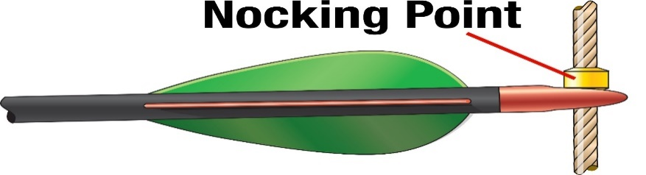

Nocking point and nock set

**Nock set height Guide**

Shooting a recurve or longbow over the bow saddle (arrow shelf)

Appox. 6/16 to 8/16 (approx. ten to 13 millimeters.

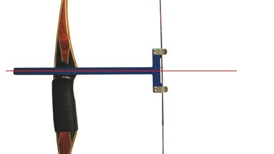

A bow square is used when setting the nock height.

**Bow strings.**

There are two main types of bow strings, Endless loop and Flemish strings, the Flemish string is the most widely used and preferred by traditional archers because they are quieter and more forgiving, they are made of several strands of string material twisted upon themselves.

Endless loop strings are mainly used on target recurves and are not the preferred string for traditional bows, the end loops are served with 1D serving and tend to be noisy compared to a Flemish string and are not suitable for a hunting setup.

String silencers are recommended, they stop the string from vibrating on release and the noise from the bow will be much quieter.

They are normally made of animal fur or a synthetic material.

**String materials**

There are several types of string material that are used for traditional bow strings, the most widely used is Dynalite, fast flight, and Dacron B50.

Always check with the bow manufacturer what is the best material to use on their bow. Today’s modern bows can except all modern string materials, but it is always wise to check first as this may have an effect your warranty.

**Bow strings**

**Bow string length**

You will hear the term A.M.O (archery manufacture organization). They created a set of standards for such things as defining bow length, It is always marked in Inches on the bottom limb. this measurement is taken from tip of the top limb to the tip of the bottom limb of an unstrung bow. The easiest wat to measure a traditional bow is to start measuring from the string groove on the belly of the bow with a soft tape and follow the curvature of the other limb to the other string groove. This will give you the A.M.O bow’s length.

For a recurve bow the string length will be four inches shorter.

For a modern longbow the string length will be three inches shorter.

For a self-bow and English Longbow, the string length will be longer.

String lengths are influenced by the brace height of the bow.

Endless loop Flemish twist

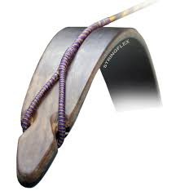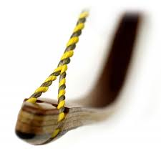

**Arrow Spine Chart**

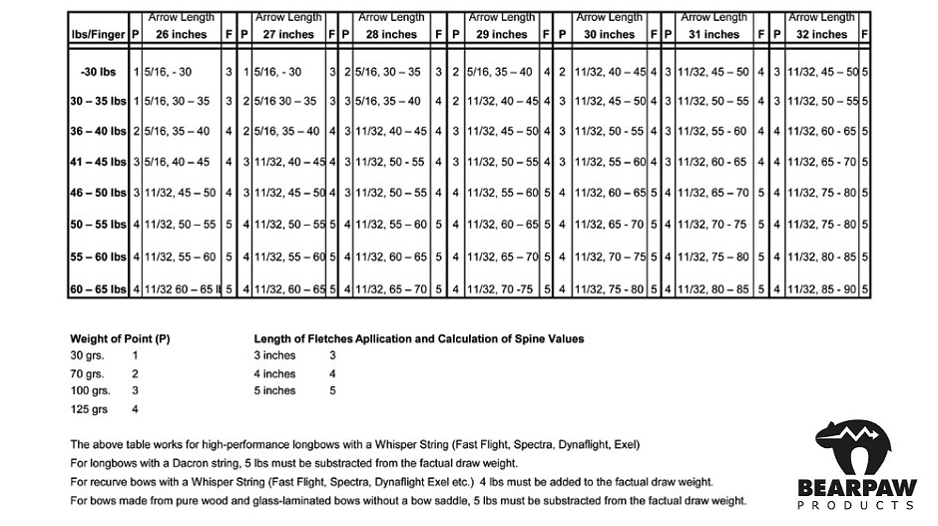

(Thank you to Bearpaw products for allowing us to use this chart).

Message from the President and Club Coach:

Welcome to the fun, exciting and at times frustrating sport of Traditional Archery. You are now part of a very large community of archers not only in Australia but world-wide.

Your club committee members will be able to guide you through your journey in this fantastic sport. We encourage you to read through this document using it as a guide to build your skills and most importantly have fun.

TAA have many clubs all over Australia. Contacting a club is as simple as checking their website for contact information. You will be welcomed at any TAA club.

If you have any questions, please contact us through:

E: Club Email Address

P: Club phone contact

Or contact us on Facebook Facebook link if the club has one

If you have any questions in relation to equipment purchase, our preferred supplier is Insert preferred supplier

P: Supplier phone number

Check with your Club Committee Members before purchasing any equipment, please!

Good luck with your archery journey 😊

Club Name President

Presidents Name

|  |
| --- |
| Your Notes: |
|  |
|  |
|  |
|  |
|  |
|  |
|  |
|  |
|  |
|  |
|  |
|  |
|  |
|  |
|  |
|  |
|  |
|  |
|  |
|  |
|  |